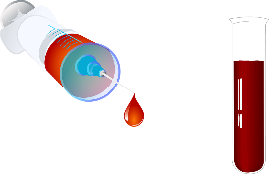 Laboratory Report

Name: Erin Johns PHN:

Date: Day 0 Age: Sex:

Doctor:

Complete Blood Count

|  |  |  |
| --- | --- | --- |
| Test Name | Result | Normal Range |
| WBC |  | 4-10 X 109/L |
| Hemoglobin |  | M: 130-170 g/L  F: 123-157 g/L |
| HCT |  | M: 0.30-0.50  F: 0.37-0.46 |
| Platelets |  | 130-400 X 109/L |
|  |  |  |
|  |  |  |
|  |  |  |

Electrolytes

|  |  |  |
| --- | --- | --- |
| Test Name | Result | Normal Range |
| Na |  | 135-145 mmol/L |
| K+ |  | 3.5-5.0 mmol/L |
| HCO3 |  | 24-30 mmol/L |
| BUN |  | 2.5-8.0 mmol?l |
| Creatinine |  | M: 70-120μmol/L  F: 50-90 μmol/L |

Arterial Blood Gas

|  |  |  |
| --- | --- | --- |
| Test Name | Result | Normal Range |
| pH | 7.45 | 7.35-7.45 |
| paCO2 | 50 | 35-45 mmHg |
| paO2 | 80 | 85-105 mmHg |
| HCO3 | 35 | 24-30 |
| SaO2 |  | 96-100% |